EXPERIMENT – 3

Install virtual Box WorkStation with Different flatforms of Linux on Windows OS on top of windows or about Downloads Virtual Box on Windows and Ubuntu

Experiment Title: Installation of Ubuntu Linux using Oracle VirtualBox

Aim:
To install Ubuntu Linux operating system on a virtual machine using Oracle VirtualBox.

Software Requirements:
- Oracle VirtualBox
- Ubuntu 24.04 LTS ISO file
- Windows Operating System

Procedure:

Download and Install VirtualBox
1.Launch a browser and look up VirtualBox online.
2.Access the official VirtualBox website.
3.Select the Download option and choose Windows as the host system.
4.Open the downloaded setup file by double-clicking it.
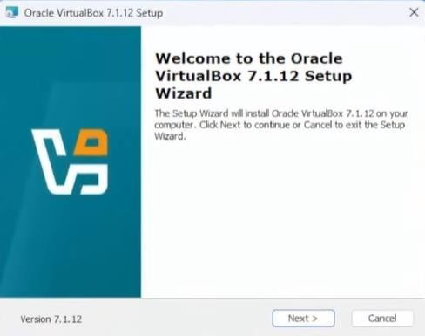
5.Proceed by clicking Next and approving the license terms.
6.Do not change any settings and click Next.
7.Approve the network interface alert by selecting Yes.
8.Begin installation and allow it to finish.
9.Click Finish to launch the application.

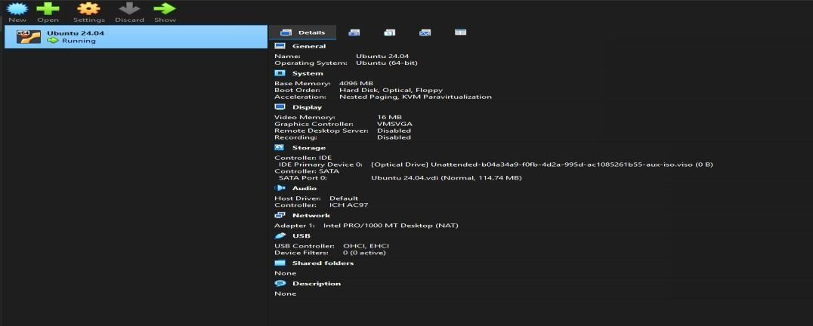

Download Ubuntu ISO File
- Open any browser and access the official Ubuntu website.
- From the Products menu, select Ubuntu Desktop.
- Press the Download button for Ubuntu Desktop.
- Select Ubuntu version 24.04 LTS.
- Wait until the ISO file download completes.

Create a New Virtual Machine

- Launch VirtualBox and select New.
- Enter Ubuntu 24.04 as the virtual machine name.
- Choose the previously downloaded Ubuntu ISO file.
- VirtualBox will automatically identify the OS as Linux / Ubuntu (64-bit).
- Create a username and password for Ubuntu access.
- Assign memory (for example, 5 GB RAM) and processor cores (for example, 4 CPUs).
- Set the virtual hard disk size (for example, 30 GB).
- Click Finish to complete the VM creation.

Install Ubuntu Operating System

- Select the virtual machine and click Start.
- Choose Try or Install Ubuntu (Safe Graphics) from the menu.
- Follow the on-screen steps and click Next when prompted.
- The installation process completes automatically.
- The system restarts once the installation is finished.
- Sign in using the username and password you created.

Adjust Display Settings (Optional)

1.From the View menu, choose Full Screen or Scaled Mode.

2.Open Display Settings in Ubuntu.

3.Select the required screen resolution and click Apply.

Result:
Ubuntu Linux operating system was successfully installed on Oracle VirtualBox.
